<https://www.w3schools.com/tags/ref_standardattributes.asp>

<https://link.springer.com/chapter/10.1007%2F978-3-642-16321-0_4>

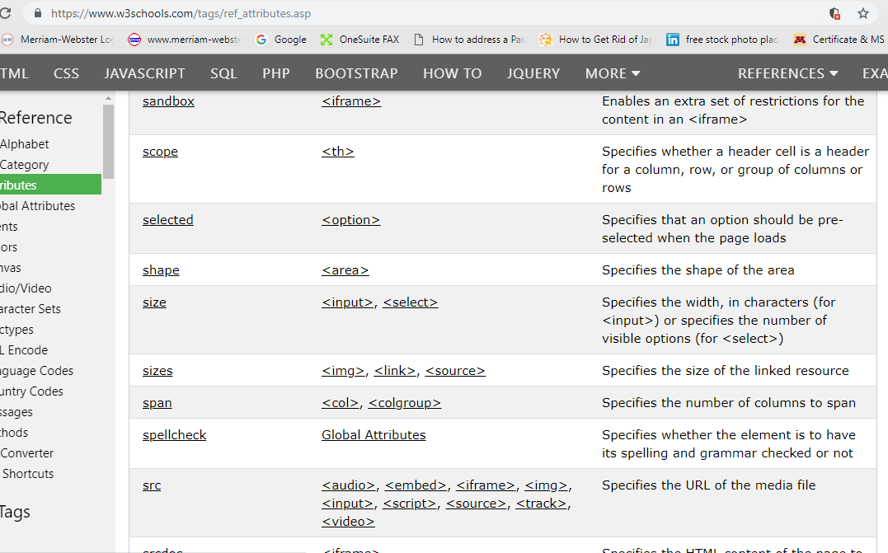

<https://www.w3schools.com/tags/tryit.asp?filename=tryhtml5_global_spellcheck>

<https://www.w3.org/TR/1998/REC-html40-19980424/html40.pdf>

https://www.w3.org/TR/html5/https://www.w3.org/standards/

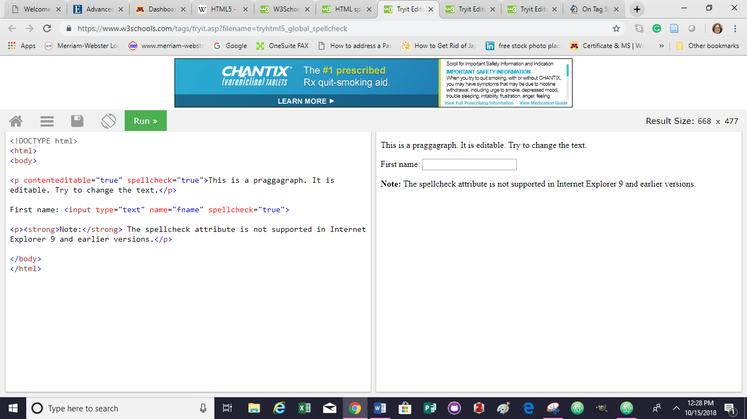

<https://www.w3.org/TR/html5/>

<https://developer.mozilla.org/en-US/docs/Web/HTML/Global_attributes/spellcheck>

<https://jsfiddle.net/0GiS0/ZU74B/> example code

<https://www.totalvalidator.com/help/spellchecking.html> use with specific langruages

<https://blog.whatwg.org/the-road-to-html-5-spellchecking#examples> \*\*\*\*https://blog.whatwg.org/the-road-to-html-5-spellchecking#examples